Spectroscopy: A Virtual Lab  
Element Identification and Emission Spectra

What you need to know:   
  
The energy levels in atoms and ions are the key to the production and detection of light. Energy levels or "shells" exist for electrons in atoms and molecules. The colors of dyes and other compounds results from electron jumps between these shells or levels, just like the colors of fireworks result from jumps of electrons from one shell to another.

Atoms have two kinds of states; a ground state and an excited state. The ground state is the state in which the electrons in the atom are in their lowest energy levels possible (atoms naturally are in the ground state). Specific amounts of energy are needed to excite an electron in an atom and produce an excited state. This energy can be added to atoms many different ways. It can be in the form of light, an electric discharge or heat. This added or extra energy is emitted when the excited electrons in the atoms give off light and fall back to lower shells. The light emitted has wavelengths and colors that depend on the amount of energy originally absorbed by the atoms. Usually each individual excited atom will emit one type of light. Different elements emit different emission spectra when they are excited because each type of element has a unique energy shell or energy level system. **Therefore every element has its own characteristic spectrum.**

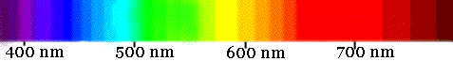  
White light is the combination of all colors of the spectrum.

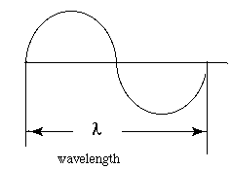  
Each color has a characteristic wavelength. The wavelength is the distance between the beginning and end of a complete cycle of the light wave. All colors of light travel at the same speed, 3.0 x 108 meters/ second. The position is determined by the wavelength

To Sum It All Up:

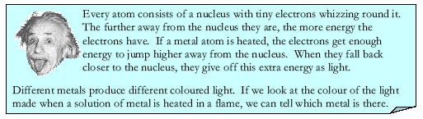  
This experiment is an exercise aimed at throwing a little more light on the subject.   
(Don't laugh too hard at the joke.)

**Part 1: Flame Tests**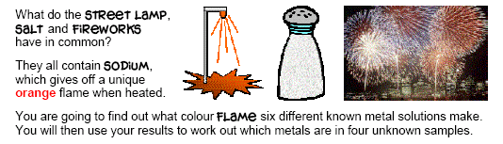

What you need to do: As each metal is heated in the flame its atoms go from the ground to excited state. The energy will be emitted when the electrons give off light and fall back to lower shells. Use the Spectroscopy Virtual Lab (Part 1: Flame tests and identification of an unknown metal) to discover the color of the flame for each known metal. Then use colored pencils to shade the What You See color of each flame and write the Flame Color. Finally, use this information to figure out the identity for the unknown metals.

|  |  |  |
| --- | --- | --- |
| Metal Ion | What You See | Observed Flame Color |
| Barium |  |  |
| Calcium |  |  |
| Sodium |  |  |
| Rubidium |  |  |
| Potassium |  |  |
| Lithium |  |  |

|  |  |  |  |
| --- | --- | --- | --- |
| Unknowns | What You See | Flame Color | Identity |
| 1 |  |  |  |
| 2 |  |  |  |

**Part 2: Emission Spectra** 

In the flame test you saw a single color as the excited atoms released the energy they gained. But there are billions of excited atoms releasing energy. The excited atoms do not all emit the same energy light because the amount of energy that excited them may differ. The kinds of light energy that can be emitted by excited atoms is unique for an element. The pattern of "lines' or colors emitted is called an emission spectrum can be used to identify an element. Astronomers also have the ability to measure amounts of an element by measuring the brightness of the emitted light.

What you need to do: Colored light is emitted by excited gases of elements in sealed glass tubes called "spectrum" tubes. (Direct current, DC, high voltage electrons are used to excite the atoms in the spectrum tube. High voltage means 1000 to 2000 volts. This is more than 10 times normal household voltage which is 120 volts AC.) A spectroscope can separate the light produced by a spectrum tube. The color seen by the naked eye is a combination of a number of colors of light. These are separated by the spectroscope’s diffraction grating to produce an emission spectrum. Use the Virtual Spectroscopy Lab (Part 2: Emission line spectra for selected elements) to observe the emission spectra for known elements and then use this information to figure out the identity of unknown elements.

  
A Mercury Spectrum Tube

|  |  |
| --- | --- |
| Element | Emission Spectrum |
| Sodium |  |
| Neon |  |
| Mercury |  |
| Helium |  |
|  |  |
|  |  |

**Check Your Understanding:**Why does a sodium vapor street light look yellow instead of white?

______________________________________________________________________________________________________________________________________________________________________________________________________________________________________________________________________________________________________________________________________________________________________________________________________________________________________________________________________________________________________________________________________________________________________________________________________________________________________________________**Part 3: Fingerprinting the Stars**

There is another way in which elements can produce spectra. Suppose that instead of a heated sample of some element, you have the element in the form of a relatively cool gas. Now let's say that a source of white light-- containing all visible wavelengths--is shining behind the gas. When photons (bursts of light) from the light source make their way through this gas, some of them can interact with the atoms--provided that they have just the right frequency to bump an electron of that element up to a higher energy level.

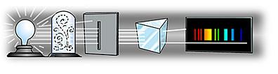

Photons at those particular frequencies are thus **absorbed** by the gas and all those other frequencies would come through okay. Then the spectrum of light that had been through the gas would just have some gaps in it, at the frequencies that were absorbed. The spectrum with these missing frequencies is called an **absorption spectrum**. Note that the dark lines in an absorption spectrum appear at exactly the same frequencies as the bright lines in the corresponding emission spectrum.

  
The Absorption Spectrum of Hydrogen

  
The Emission Spectrum of Hydrogen

What does this have to do with stars?  
If you look more closely at the Sun's spectrum, you will notice the presence of dark lines. These lines are caused by the Sun's atmosphere absorbing light at certain wavelengths, causing the intensity of the light at this wavelength to drop and appear dark. The atoms and molecules in a gas will absorb only certain wavelengths of light. The pattern of these lines is unique to each element and tells us what elements make up the atmosphere of the Sun. We usually see absorption spectra from regions in space where a cooler gas lies between us and a hotter source. We usually see absorption spectra from stars, planets with atmospheres, and galaxies. Astronomers also have the ability to measure amounts of an element present in an object by measuring the thickness of the dark lines.

Detailed image of our Sun's Absorption Spectrum

**Check Your Understanding:**Here are spectra for some elements common in the atmospheres of stars:









Below you will see both the elements for comparison and a star's spectrum. Your job is to identify all the elements you can detect in the star's atmosphere.

|  |  |
| --- | --- |
| Mystery Star Spectrum | Elements Present |
|  |  |
|  |  |
|  |  |
|  |  |
|  |  |
|  |  |
|  |  |

You have identified all the elements we can see in the star's spectrum. Real spectra are more complex, but now you have the basic idea.

In your own words: Explain how astronomers use spectrographs to identify the composition and movement of a star.

________________________________________________________________________________________________________________________________________________________________________________________________________________________________________________________________________________________________________________________________________________________________________________________________________________________________________________________________________________________________________________________________________________________________________________________________________________________________________________________________________________________________________________________________________________Closure:

Identify the elements present in A, B, and C by comparing the bright lines present with the bright lines in the spectra for known elements.

